Configuring the VTY Lines with Access Control List

How to secure VTY LINES WITH ACLs

Inacio Andre

2024

// TOPOLOGY //

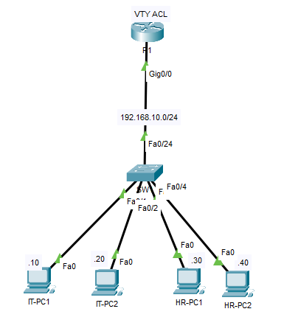

// BASIC CONFIGURATION //

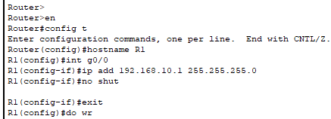

// SSH CONFIGURATION //

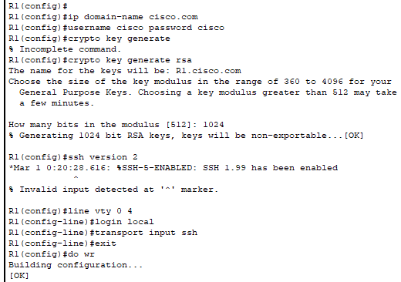

// TESTING SSH //

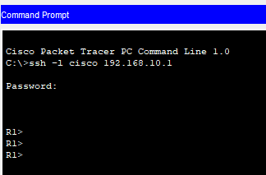

// ACL CONFIGURATION //

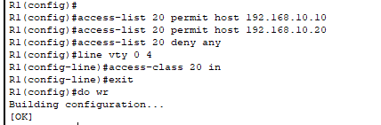

// TESTING COMMUNICATION AFTER ACL CONFIGURATION //

HR-PC 1 TO R1

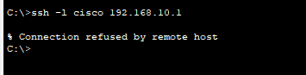

IT-PC1 T0 R1

